ActiveX TraceTool API Documentation

Introduction 1
Tracetool client configuration 2
API documentation overview 3
CoClass 4
IXTrace 5
IXTraceOptions 5
IXTraceToSend 5
IXTraceNode 5
IXTraceNodeEx 6
IXMemberNode 6
IXWinTrace 6
IXWinWatch 6
IXTraceTable interface 6

Introduction

License information: You are free to distribute the viewer (GPL) and to incorporate the library (LGPL) in your product (commercial or not). The only thing you can't do is to sell the viewer (or a modified version) and the API as a tracing solution.

Six frameworks are currently supported: Dot net (C#), Java , JavaScript, Delphi for window , C++ and ActiveX
Since theses languages are different, the syntax and the options are a little bit different.

C#: TTrace.Warning.Send ("Hello");
Java: TTrace.warning ().send ("hello");
Delphi: TTrace.Warning.Send ('hello');
C++: TTrace::Warning ()->Send ("Hello");
Javascript : ttrace.warning().send(“Hello”);
ActiveX : Depends from the host (script , VB, …)

See the corresponding TraceTool API documentation’s for more details on theses languages.
The ActiveX library is a wrapper around the Delphi tracetool API.

The entry point of the framework is the TTrace class.
That class provide 3 invisible parents node (Debug, Warning and Error) with specific icon and with the “Enabled” property set to true.
TTrace has some global functions, like clearAll () to clear all the traces and show () to show or hide the viewer

The framework gives the possibility to create multiple Tab traces, see the WinTrace class.

TraceTool propose 2 ways to send traces:
- TraceToSend
- TraceNodeEx

In TraceNode mode, traces are sent from a Parent node. (debug, warning and error)
It’s the quicker way to send normal traces.

The problem with TraceToSend is that this class cannot provide hundreds of overload methods to match the developer needs.
For example Send (“Col1”, “Col2”, Type) or Send (“col1”, IconIndex) .
It’s where TraceNodeEx is needed.
In this mode, TraceNodeEx is created first, filled by the developer and then sent.
Using TraceNodeEx, you can specify left and right column separately, give an icon and add some information onto the “member” pane, like dumps, class type, object or stack information on a single trace. The constructor has one parameter: TraceToSend’s parent Node. If supplied, the trace is added under the ParentNode and receives the same IconIndex and Enabled properties.

Tracetool client configuration

Configuration of the TraceTool client application can be done using the TraceTool.config file.
Since the activeX library is a wrapper around the Delphi library, he inherit the same functionalities.

Sample TraceTool.config file :

DebugEnabled=true
WarningEnabled=true
ErrorEnabled=true

This file is optional and all the properties are also optional. Properties and values are not case sensitive.

Param name | Meaning
SendMode | WinMsg or Socket. Default is WinMsg
SocketHost | Url of the host. Default is 127.0.0.1
SocketPort | Destination port. Default is 8090
SendFunctions | Send functions. Default is False
SendInherited | Send inherited members. Default is False
SendEvents | Send events. Default is False
SendProcessName | Send process name. Default is False
ObjectTreeDepth | Max Object tree depth for sendValue and Watches
DebugEnabled | Enable Debug entry. Default is true
WarningEnabled | Enable warning entry. Default is true
ErrorEnabled | Enable error entry. Default is true

See the Option class documentation later in this document or the ActiveX-TraceTool.chm file.

Multi column support

The original framework allows you to send 2 columns of information (including thread name, icon and date).
Since the Log4J/Log4Net support, it’s now possible to send as many columns of data as you want, but with a small restriction:
Multi column is not supported in the main trace window, since many applications (and in different languages) cannot share the main window in “classic” mode and in “multi column” mode.

You must then create a window trace and set the titles. (with just a few lines)

In that mode, of course, you have to send yourself the thread name and date if you need it.

Sending many columns of text is performed with the same API as for simple trace.
Just add a tabulation (“\t”) between the different columns.

See the WinTrace documentation.

API documentation overview

The framework defines a lot of public classes, but you need to learn only the IXTraceToSend interface for to the majority of the traces.

Traces can be done in 1 line of code :
TTrace.warning ().sendValue ("My Object", myObject);

The following diagram exposes the public classes. See the ActiveX-Tracetool.chm help file for full API documentation.

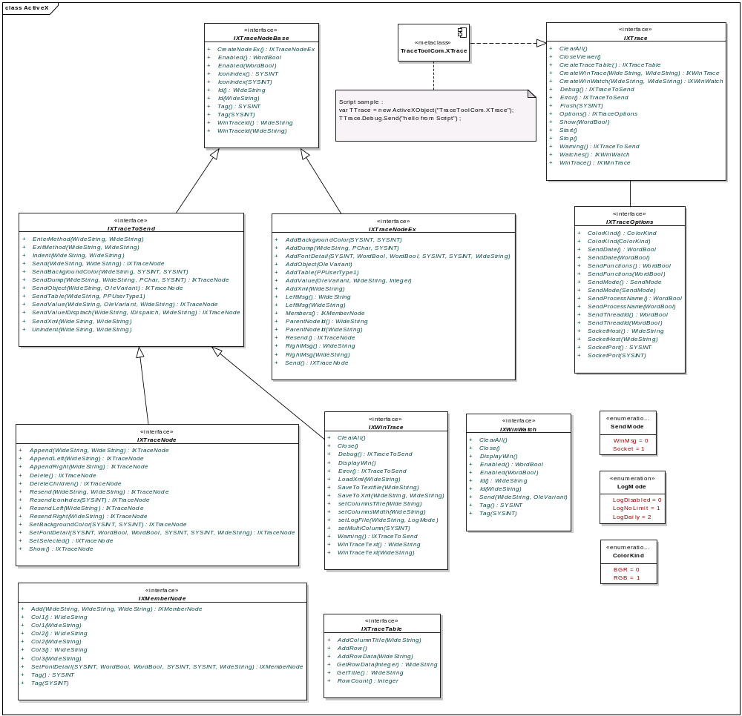

CoClass

Like all activeX library, you must retrieve the main object interface, in this case the IXTrace interface (depends of the host language).

Jscript:

var TTrace = new ActiveXObject("TraceToolCom.XTrace");
TTrace.Debug.Send("hello from jScript") ;

Delphi:

- Delphi5-6-7 : Project/Import Type Library
Delphi2006-2007 : Component/Import component then select “Import type library”
- Select the library : TraceToolCom library and follow instruction
- Delphi will create the TraceToolCom_TLB.pas file
- Add TraceToolCom_TLB in the uses list.
- Sample :

uses TraceToolCom_TLB;
…
var
TTrace : IXTrace ;
Begin
TTrace := CoXTrace.Create ;
TTrace.debug.Send('hello2','') ;
End ;

VB:

- Import type library : right click Project then properties. In the reference tab, click 'add',
select 'COM' then tracetoolCom 9.0 library
- On top of your vb file, add the Imports statement with TraceToolCom
- Sample :

Imports TraceToolCom
…
Private Sub Form1_Load(ByVal sender As System.Object, ByVal e As System.EventArgs) Handles MyBase.Load
' instanciate tracetool system
TTrace = New XTrace()
' tracetool need to know how colours are coded
TTrace.Options.ColorKind = ColorKind.RGB
TTrace.Debug.Send("hello", "world")
End Sub

IXTrace

IXTrace is the entry point for all traces. He gives 3 'TraceToSend' doors: warning(), error() and debug().
Theses 3 doors are displayed with a special icon. All of them have the 'enabled' property set to true.
You can set it to false to limit logging. That class is fully static.

This class also represent the viewer:
- Clear messages on the main window.
- Show / hide / close the viewer.
- Give access to the main trace window, the main watch window
- Give access to the main debug, warning and error node.
- Function to create new Window trace, Watch Window and Table on the viewer

IXTraceOptions

Options for the traces, accessible from TTrace.Options

Public fields :

Options for the traces, accessible from TTrace.Options:
- Change the way traces are send : windows messages or socket messages
- Change Socket host and port
- Indicate if the process name must be send. Displayed on the status bar. Default is false.
- Indicate if the date must be send.
- Indicate if the reflection should display functions , inherited members and events
- Specify how your colour is coded : RGB or BGR

The default Host is LocalHost on the 8090 port.
The default colour schema is 0 : BGR.

IXTraceToSend

The API provides predefined IXTraceToSend objects and some ways to create IXTraceToSend objects.
The TTrace.Debug , Warning and Errors object for example are IXTraceToSend object you can use :

TTrace.Debug.Send (“Hello”, “World”) ;

IXTraceToSend inherit from IXTraceNodeBase:
- Trace id
- Enabled flag
- Index of the icon to use.
- The window where trace is send.
- User variable (Tag) , provided for the convenience of developers
- Function to create a IXTraceNodeEx child

IXTraceToSend allow you to send :
- Simple messages (1 or 2 columns).
- Indented messages (see Indent, UnIndent, EnterMethod and ExitMethod).
- Objects values
- Dump
- Tables
- Xml.

All methods of this class send traces and return an IXTraceNode object.

IXTraceNode

IXTraceNode object represent a node already send on the viewer. You can :
- Resend left and/or right message to the viewer
- Append text to the left and/or right
- Show or select the node
- Delete the node or delete children node
- Change font detail

IXTraceNodeEx

Alternate ways to send traces: prepare a IXTraceNodeEx with all properties and then send it.
IXTraceNodeEx inherit from IXTraceNodeBase.
The main difference between AddXXX method and SendXXX method is that SendXXX create a new child trace that is directly send.
AddXXX method must be called from an existing TraceNodeEx object. You can call many AddXXX on that object and then send it.
Call CreateNodeEx on a parent Node (defined in IXTraceNodeBase) to create an IXTraceNodeEx instance.

IXTraceNodeEx inherit from IXTraceNodeBase:
- Trace id
- Enabled flag
- Index of the icon to use.
- The window where trace is send.
- User variable (Tag) , provided for the convenience of developers
- Function to create a IXTraceNodeEx child

IXTraceNodeEx define:

- Left message , right message,
- Parent node id
- Message Time
- Message Tread name
- Members (information panel). See TMemberNode class
- Function to add Object information
- Stack information
- Dump
- Tables and string list
- Xml.
- A “Send” method that send the trace to the viewer
- A “Resend” method that resend the left and right message.

The send method returns an IXTraceNode object.

IXMemberNode

IXMemberNode represent a node information in the "info" panel.
Members are available in IXTraceNodeEx objects.
Use one of the AddXXX methods to create members or use TMemberNode constructors then add to members

IXWinTrace

Represent a trace window in the viewer. IXTrace use an IXWinTrace object for the main trace window.
To create an IXWinTrace instance, use the IXTrace.CreateWinTrace method. The main page can be accessed using IXTrace.WinTrace

WinTrace objects let you manage traces in that window :
- Clear messages
- Set log file
- Save to text or xml files
- Load from xml files
- Change columns

IXWinWatch

Represent a Watch window in the viewer. The main Watch window can be accessed using IXTrace.Watches
To create an IwinWatch instance, use the TTrace.createWinWatch method.

Watches are languages independents: you can send a delphi Watch to the viewer that can be changed by a Java application.
The number of objects displayed by recursion is dependent of the ttrace.options.objectTreeDepth variable
This interface also represent a watch window on the viewer :
- Display the window
- Clear all watches

IXTraceTable interface

Construct a table of row to display in the viewer on a node.
The table must be associated with a node.
See IXTraceNodeEx.AddTable() and IXTraceToSend.SendTable()

